**USE CASE DIGRAM AND USE CASE SCENARIO FOR HOSPITAL MANGMENT SYSTEM**

**USE CASE DIGRA**

[**https://app.creately.com**](https://app.creately.com) **I use this site to create digrame :**

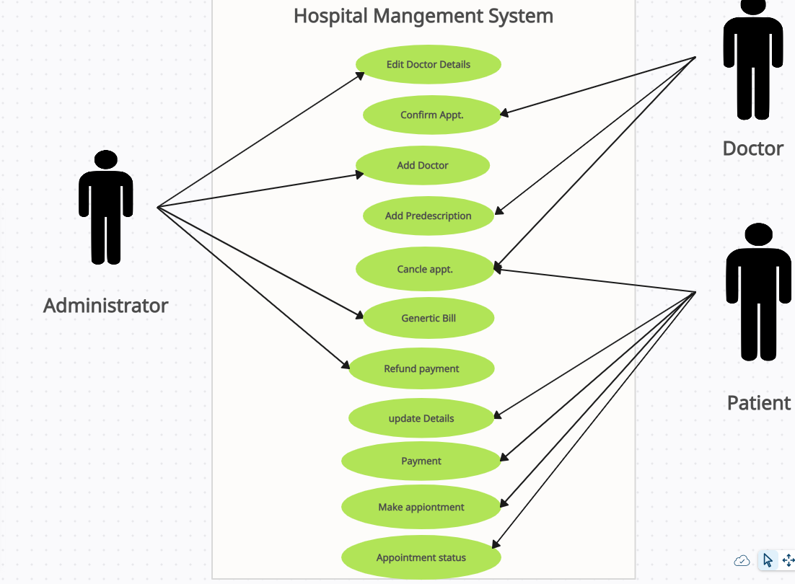

**USE CASE SCENARIO:**

**(1) PATIENT**

**\* REGISTRATION**

DESCRIPTION - The new patient can register themselves and add their details like name, age , gender, blood group etc. The patient entry will be made in the hms database. PRE -CONDITION – The patient must be a new patient, If necessary fields left by user then prompt user to fill the necessary fields. MAIN FLOW OF EVENTS 1. Patient selects sign up in login module. 2. A registration form get displayed 3. Patient fills the required details. POST CONDITIONS - Patient record is added to hms database.

**\* UPDATION**

DESCRIPTION-The patient should be enabled to update his/her details and the changes should reflect in hms database. PRE-CONDITION – The patient must be a registered patient, The patient cannot update details after treatment starts. MAIN FLOW OF EVENTS 1. Patient logs in to the system. 2. Patient view his record 3. Patient selects update details. 4. Now patient may change the necessary fields. 5. Pop of update details. POST CONDITION - The record of patient is updated in hms database.

**\*APPOINTMENT**

DESCRIPTION - It shows users a list of available doctors, timings, dates and enables patients to select the most suitable appointment date and doctor. The patient may also the cancel the appointment. PRE-CONDITION - The patient must be a registered patient, Patient can fix only one appointment for a particular department. MAIN FLOW OF EVENT 1. Patient first logs in to system. 2. View his/her record. 3. Create a new appointment or cancel the appointment.. POST CONDITIONS - patient details are displayed and a new appointment is fix or a existing appointment is cancelled. The hms database is updated.

**\*PAYMENT**

DESCRIPTION – It enables user to pay the consultant fee of Doctor online. PRE-CONDITION - The patient must be a registered patient, If Patient don’t wants to pay online he/she can pay by cash also. MAIN FLOW OF EVENT 1. Patient first logs in to system. 2. View his/her record. 3. Appointment confirmed by the Doctor then go for Payment. POST CONDITIONS – A Reciept will be displayed. The hms database is updated.

**(2) DOCTOR**

**DESCRIPTION**- The doctor view patient record/ update his details and add description of the treatment given to patient.

**PRE-CONDITION** – The doctor must be a registered doctor, System does not allow the doctor to modify the qualification, hospital managed details.

**MAIN FLOW OF EVENT**S 1.Doctor logs in to the system. 2. Doctor may select view patient. 2.1 Patient record is displayed with treatment history. 3. Doctor add description of patient treatment. 4. Doctor may select appointment details 4.1 Appointment Requests is displayed with schedule. 5. Doctor confirm or cancel appointment.

**POST CONDITION** – The patient and doctor ‘s database are updated.

**(3) ADMINISRAETOR**

**DESCRIPTION** - The admin add doctor, update docotr details and verify payment and generate Bill/Reciept for the same.

**MAIN FLOW OF EVENTS**

1. Admin logs in the system.

2. Admin may add doctor new doctor.

2.1 admin fills the doctor’s details.

3. Admin view Doctor record.

3.1 Admin enters the doctor id in the system.

3.2 Doctor details are displayed, Admin can update details

. 4. Admin Verify the payment submited by the Patient.

4.1 Generate Bill/Reciept and confirmation message for the same. PRE –CONDITION - Admin must first log in with his/her credentials.

**POST CONDITION** - The hms database is updated